# Statistical Analysis and Data Visualization application

# IDS 517: s18t23

# Submitted by Vidhi, Sumeet and Ishaan

This is an application to perform Descriptive Statistical Analysis and Visualization. The application enables user to upload/select a file, run statistical analysis and visualize patterns through graphs. The functionalities include accepting a valid user's selected file, querying within the file and displaying appropriate results in form of visual graphs.

# User's Guide

**Application Login-page**

Login using username, password, Host and Database.

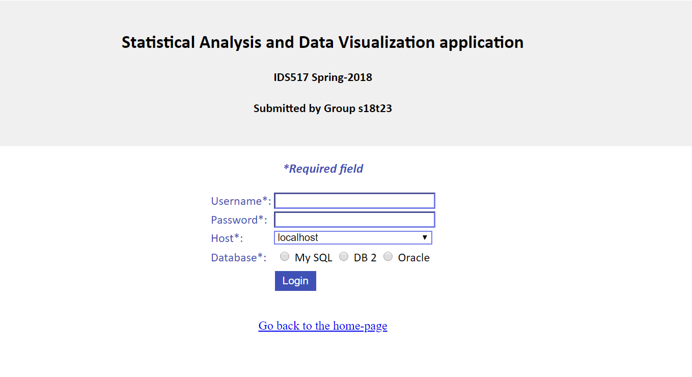

**Application Home-page**

Successful Login will redirect you to the Application home page. Choose the appropriate function.

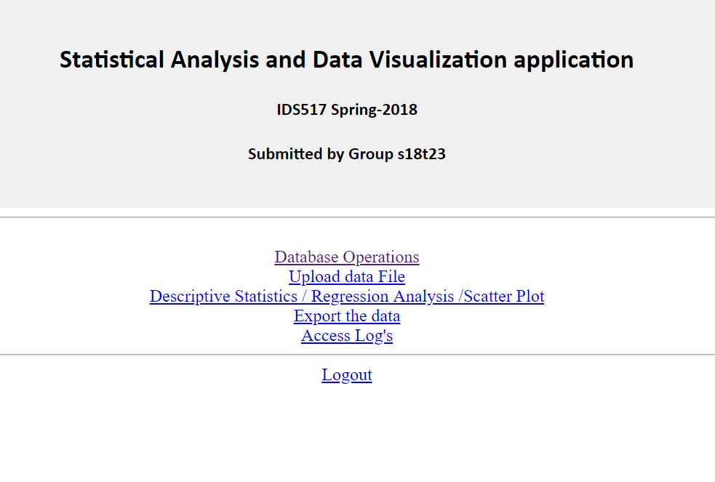

**Database Operations**

Select the table -> View table -> execute given function or write sql query

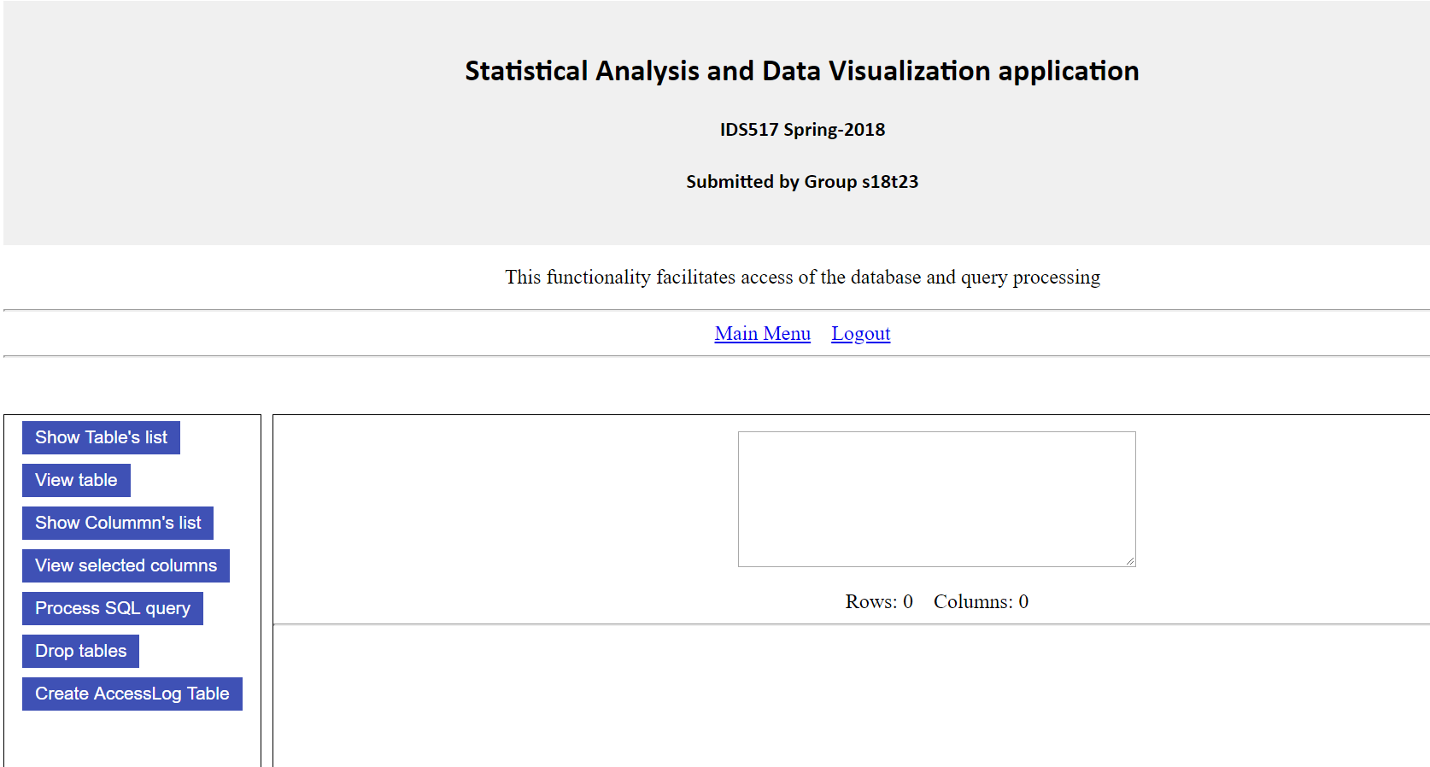

**Upload data File**

Upload tab delimited file or CSV file. Go to database operations tab and ensure data is uploaded.

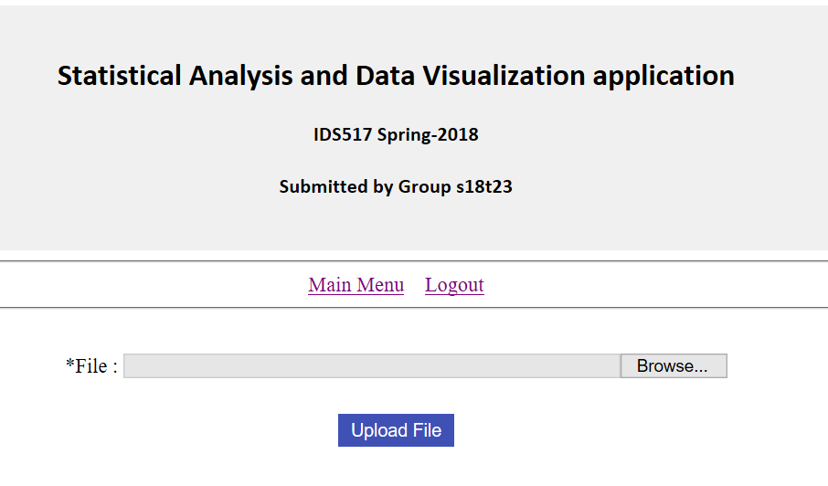

**Descriptive Statistics / Regression Analysis /Scatter Plot**

Perform Descriptive statistics, Regression Analysis and plot scatter plot

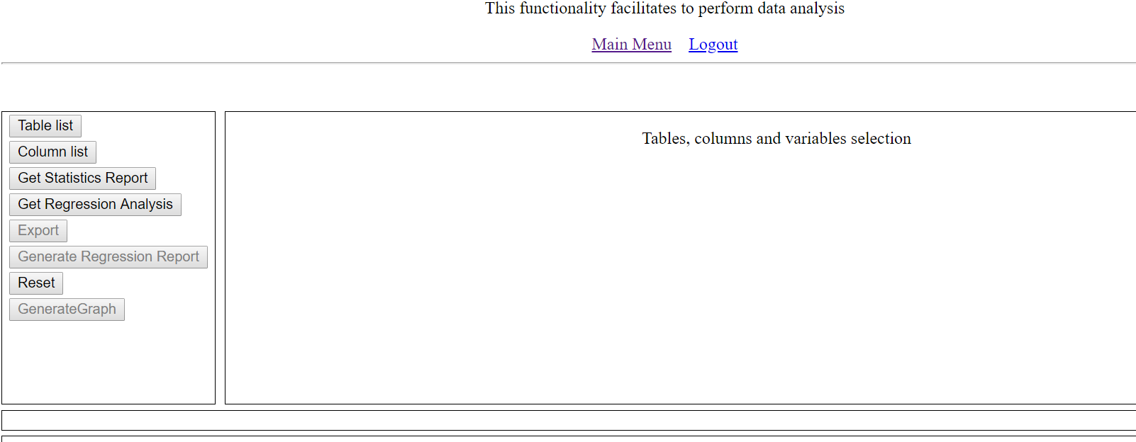

**Export the data**

Export the table data in csv and tab delimited file format

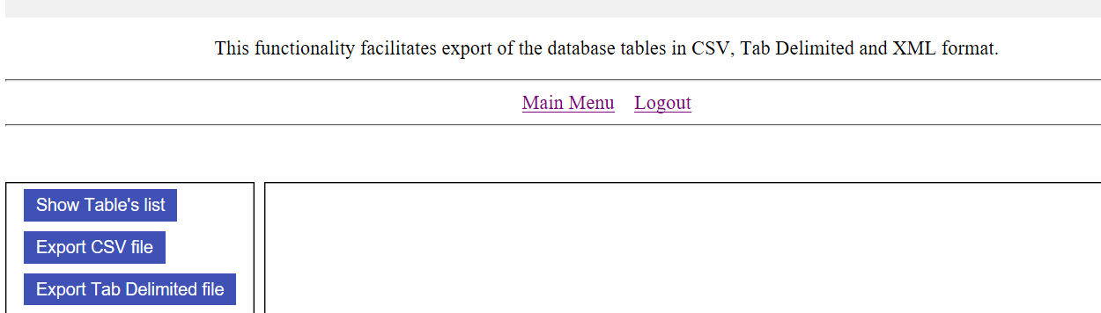

**Access Log's**

Access the log file

